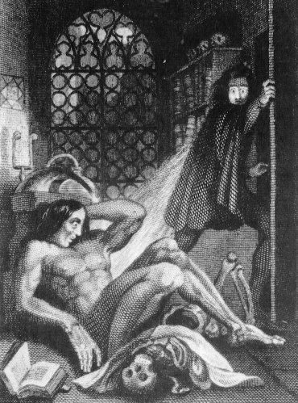
Frankenstein’s Secrets:
The Science, The Scandals, The Monster
The Rosenbach of the Free Library of Philadelphia 2008-2010 Delancey Place Philadelphia, PA 19103

Prof. Siobhan Carroll, University of Delaware, sicarrol@udel.edu
Assistants:
Petra Clark - pbclark@udel.edu
Samantha Nystrom – snystrom@udel.edu
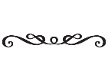
“About 200 years ago, a runaway teenager awoke from a nightmare. Encouraged by her lover – a man married to another woman – she wrote down her dream, and in the process created a story that continues to haunt us today. In these 4 class sessions we will explore the secret history of Frankenstein, learning about the sexual politics and scientific controversies that animated Mary Shelley’s masterpiece. We will also explore Frankenstein’s longevity, identifying where and how this Gothic tale has shaped our culture.”
Recommended edition: Frankenstein: The 1818 Text. Ed. Butler, Oxford University Press.

Reading Schedule
Oct 22. Session 1: Gender and Sexuality
Readings – Frankenstein to the end of Volume 1/pg 68; Wollstonecraft’s Vindication excerpt (pdf)
Extra reading (if you feel like it): Anne K. Mellor’s Mary Shelley: Her Life, Her Fiction, Her Monsters
Oct. 29. Session 2: Scientific Monsters
Readings – Frankenstein to the end of Volume 2 Ch 9/ pg 118
Nov. 5. Session 3: Empire and its Others
Readings – Frankenstein to the end of the book
Nov. 12. Session 4: Frankenstein’s Monsters
Reading TBA

